 | 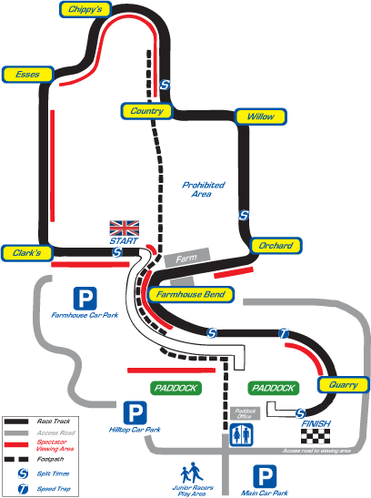 |  | t
  Best start times R1 | Best times to just before Country Corner | Best times from Country to Orchard | Best times from Orchard to just after Farmhouse | Best times from just after Farmhouse to Finish
  Pauline Goodwin 2.36s | Richard Allen 26.43s | Nick Frost 14.26s | Richard Prior 16.20s | Richard Prior 10.65s
  Richard Preece 2.37s | Nick Taylor 27.01s | Richard Prior 14.47s | Nick Frost 16.28s | Nick Frost 10.69s
  Richard Allen 2.42s | Nick Frost 27.24 | Nick Taylor 14.67s | Nick Taylor 16.46s | Mark Buckland 10.89s
  Geoff Dark 2.50s | Phil Whitehead 27.45s | Richard Allen 14.83s | Brian Jackson 16.50s | Richard Allen 10.92s
  Nick Taylor 2.57s | Brian Jackson 27.47s | Phil Whitehead 14.87s | Richard Allen 16.51s | Nick Taylor 11.11s
  Best start times R2 | Best times to just before Country Corner | Best times from Country to Orchard | Best times from Orchard to just after Farmhouse | Best times from just after Farmhouse to Finish
  Pauline Goodwin 2.34s | Richard Allen 26.66s | Richard Prior 14.22s | Phil Whitehead 16.11s | Nick Frost 10.80s
  Richard Allen 2.35s | Nick Frost 26.75s | Nick Taylor 14.31s | Nick Frost 16.14s | Richard Allen 10.88s
  Geoff Dark 2.38s | Nick Taylor 26.91s | Nick Frost 14.37s | Nick Taylor 16.31s | Mark Buckland 10.97s
  Richard Preece 2.49s | Geoff Dark 27.11s | Richard Allen 14.64s | Richard Prior 16.33s | Richard Prior 10.98s
  Nick Taylor 2.49s | Phil Whitehead 27.18s | Phil Whitehead 14.67s | Richard Allen 16.52s | Nick Taylor 11.15s

